R Reference Sheet
Downloading R:
Use this website to download R and R studio for free:
https://posit.co/download/rstudio-desktop/
It will give you the option to download R and R studio. Download both and follow the order by installing R first and then RStudio.

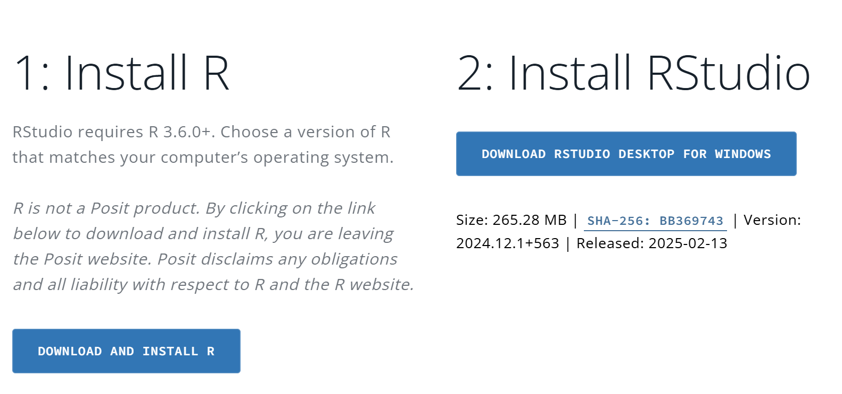

If you do not have Windows, scroll down on the website page and there will be more options for downloading RStudio:
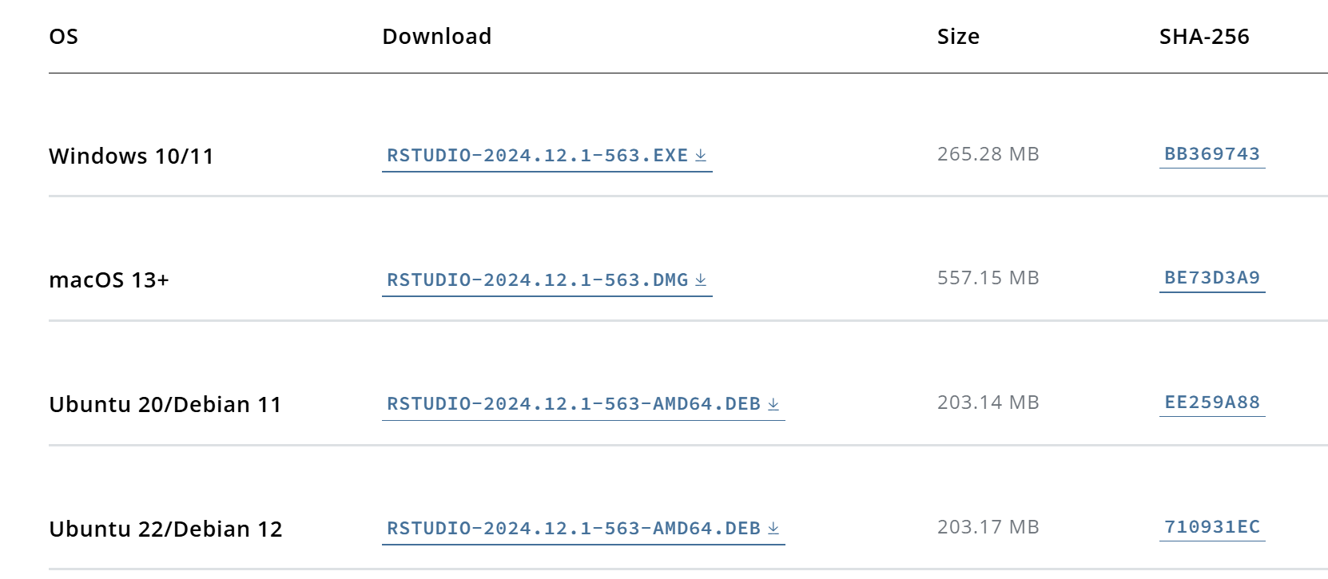
Why Do You Need Both R and RStudio?
- R is the core programming language that does all the computations.
- RStudio is an IDE (Integrated Development Environment) that makes working with R easier by providing features like a script editor, console, data viewer, and visualization tools.
Think of it like this: R is the engine, and RStudio is the car dashboard that makes driving (coding) smoother.
Once installed, open RStudio—it will automatically connect to R, and you're ready to start coding!

Code Explanations:

Basics of R
1. Comments
- Comments in R start with #. They are ignored by the program but help explain the code.
2. Functions
- Functions perform specific tasks and take inputs (arguments).
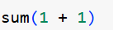
Here, the sum function is a tool that will add our two numbers together for us once run.
3. Packages
- Packages extend R’s capabilities with additional functions and tools.
For example, to plot data we usually need the ggplot2 package to use tools or functions within it to help us plot data.
To install it, we would run:
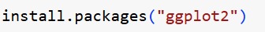
The install.packages function allows us to install ggplot2 to use its functions. Whenever we are installing a package, we must put its name in quotations.
4. Installing and Loading Packages
- Install a package (only needs to be done once):
5. Getting Help
- Use ? before a function to see its documentation.
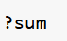
If you do not understand what a function means, you can use a question mark in front of it and R will give you an explanation of what it does:

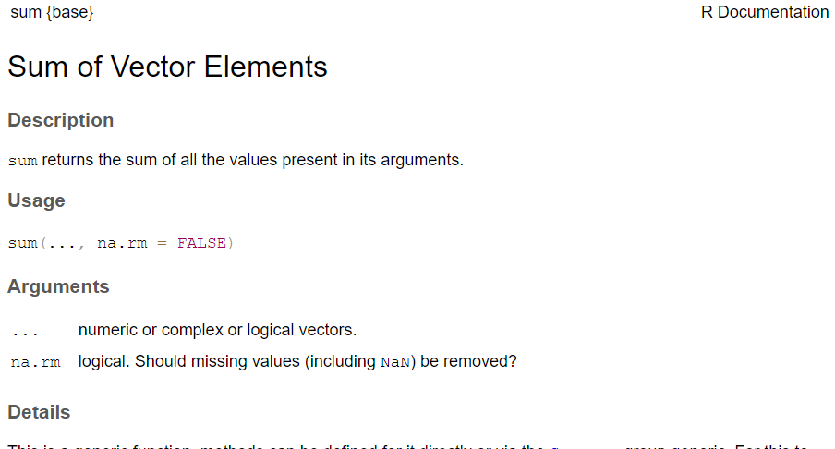

These fundamentals will help you start writing and understanding R code with confidence! Plus, ChatGPT can be an excellent tutor for learning R—you can ask it to troubleshoot errors, generate practice problems, and even write R code for you!
However, it's crucial to understand the fundamentals of R rather than relying solely on ChatGPT. Sometimes, ChatGPT may generate code that doesn’t run correctly, and having a solid grasp of R will help you identify issues and effectively communicate what needs to be fixed.

Basic Arithmetic
R supports basic arithmetic operations:
- `+` Addition
- `-` Subtraction
- `*` Multiplication
- `/` Division
Example:
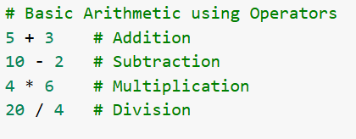

Variables
Variables store values for later use.
Example:
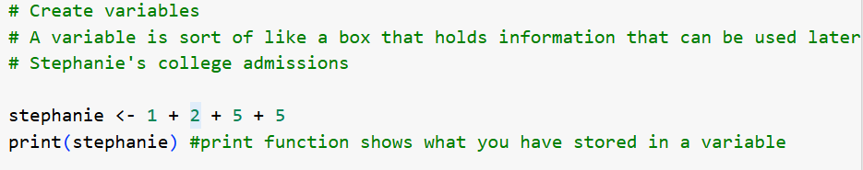

Vectors
Vectors are lists of elements of the same type.
Example:
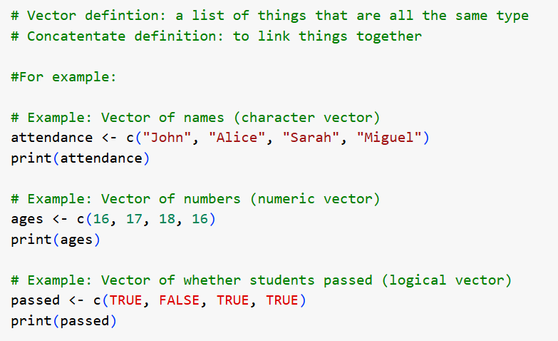

Data Frames
Data frames store tabular data. Instead of having multiple lists and conducting analyses or operations on each of those lists, putting them together in a data frame allows for easier organization, manipulation, and analysis.
Example:
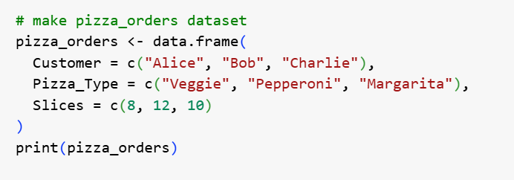

Example of a data frame:
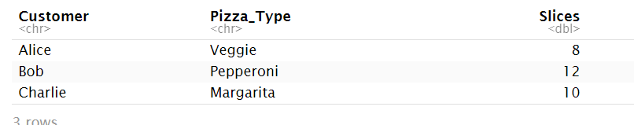

Reading Files
To work with data frames, you will have to know how to open up your data files!
In our workshop, we will use `read.csv()` to read CSV files.
Example:
Here are a few other functions for reference depending on the type of data file you are working with:
CSV & Text Files
- read.csv("file.csv") – Reads a CSV file into a data frame.
- read.delim("file.txt") – Reads a tab-delimited text file.
- read.table("file.txt") – Reads general text files with customizable delimiters.
- fread("file.csv") (from data.table package) – Fast reading of large CSV files.

Excel Files
- read.xlsx("file.xlsx", sheetIndex = 1) (from xlsx package) – Reads Excel files.
- read_excel("file.xlsx") (from readxl package) – Reads Excel files without Java dependency.
R Data Files
- load("file.RData") – Loads RData files containing saved objects.
- readRDS("file.rds") – Reads an RDS file into an R object.
SPSS, SAS, and Stata Files
- read_spss("file.sav") (from haven package) – Reads SPSS files.
- read_sas("file.sas7bdat") (from haven package) – Reads SAS datasets.
- read_dta("file.dta") (from haven or foreign package) – Reads Stata files.
JSON & XML Files
- fromJSON("file.json") (from jsonlite package) – Reads JSON files.
- xmlParse("file.xml") (from XML package) – Reads XML files.
SQL Databases
- dbReadTable(con, "table_name") (from DBI package) – Reads a table from an SQL database.
- dbGetQuery(con, "SELECT * FROM table") (from DBI package) – Runs a query and retrieves results.

Scatterplots
Use `plot()` to create scatterplots to visualize your data. Example:
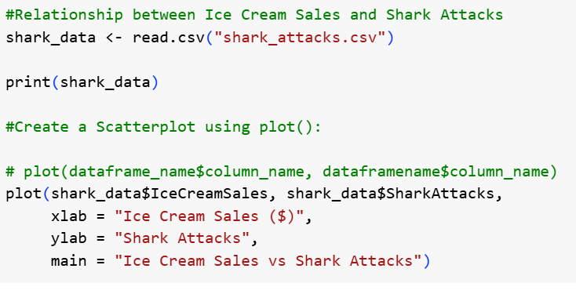
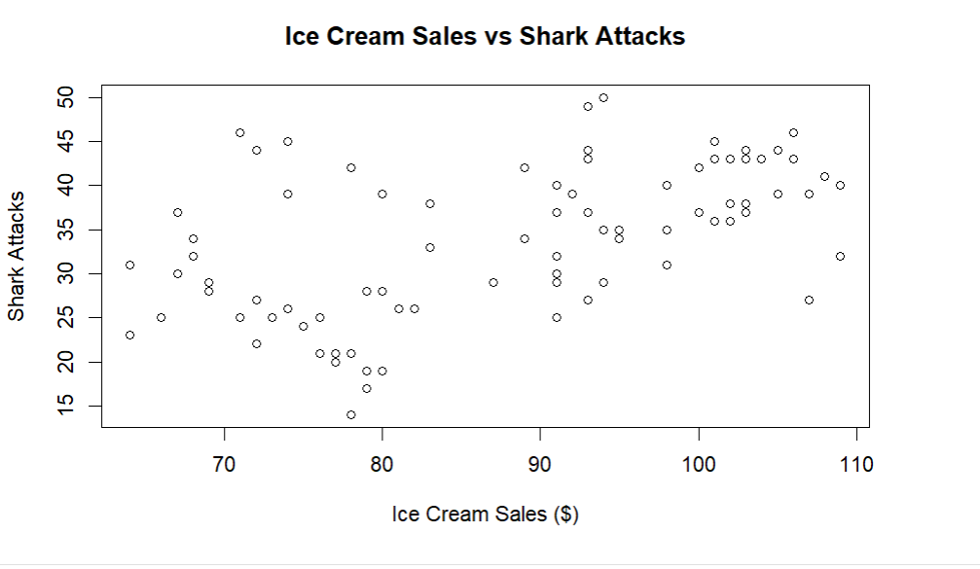

Correlation
Use `cor()` to find correlations between variables.
Understanding Correlation in R
The cor() function in R is used to measure the correlation between two variables. Correlation tells us how strongly two variables are related and whether changes in one variable correspond to changes in another.
Types of Correlation:
- Positive Correlation – When one variable increases, the other also increases.
  - Example: Study time and test scores (more study time → higher scores).
- Negative Correlation – When one variable increases, the other decreases.
  - Example: Stress and sleep (more stress → less sleep).
- No Correlation – No clear relationship between the two variables.
  - Example: Shoe size and intelligence (unrelated).
Example:
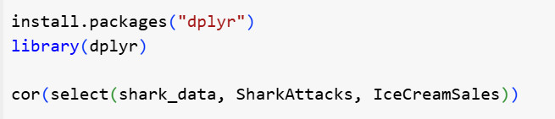
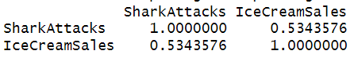
Interpreting Correlation:
Correlation Coefficient (r) | Strength of Relationship
0.90 to 1.00 or -0.90 to -1.00 | Very strong correlation
0.70 to 0.89 or -0.70 to -0.89 | Strong correlation
0.40 to 0.69 or -0.40 to -0.69 | Moderate correlation
0.10 to 0.39 or -0.10 to -0.39 | Weak correlation
0.00 to 0.09 or -0.00 to -0.09 | No or very weak correlation
A correlation of 0.53 between shark attacks and ice cream sales indicates a moderate positive correlation between the two variables.
What Does This Mean?
- Since the value is positive, it suggests that as ice cream sales increase, shark attacks also tend to increase.
- However, a correlation of 0.53 does not mean that ice cream sales cause shark attacks—it just shows an association.
- This could be due to a third variable, like temperature. Hotter weather leads to more people buying ice cream and more people swimming, increasing the chance of shark attacks.

Linear Models and Variation
Variation is essential in linear models because it helps us understand relationships between variables. A linear model examines how changes in one variable (e.g., ice cream sales) predict changes in another (e.g., shark attacks). If there is a consistent pattern in the variation, the model can create a best-fit line to describe this relationship, allowing us to make predictions based on the data.
- Variation refers to how much data points change.
- Linear models analyze how one variable affects another.
- Best-fit lines help describe relationships and make predictions.
- Example: If ice cream sales and shark attacks increase together, a model can help determine the strength of this relationship.

Use lm() to create a linear regression model. In R, the format for a linear model is Y ~ X. If we want to determine how much variation in shark attacks can be explained by ice cream sales, we would use the following code:
Example:
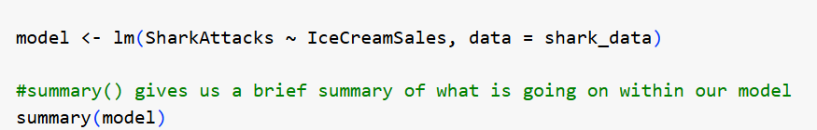
Which would give us this output:
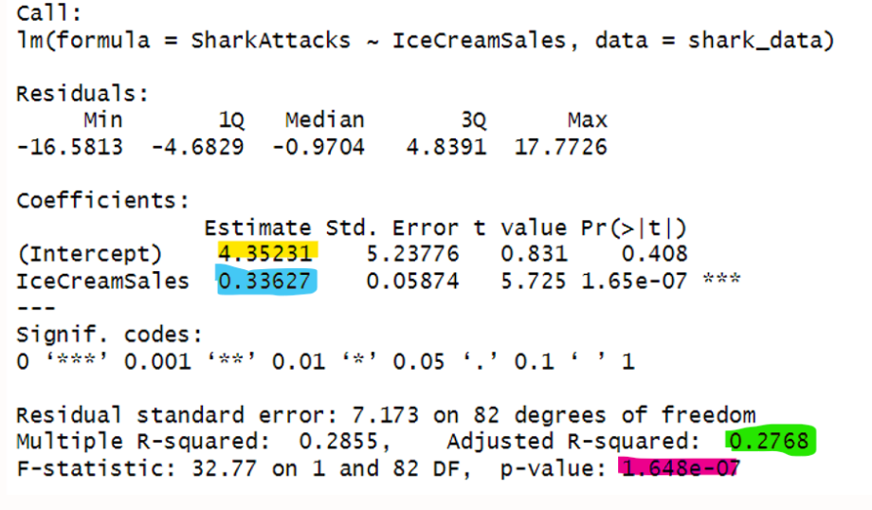
There’s a lot of output here but for a brief intro to some of the statistics:
Intercept (4.35): This is the predicted number of shark attacks when ice cream sales are zero. While it might not make practical sense, it's part of the math behind the model.
IceCreamSales Coefficient (0.34): For every additional unit of ice cream sales, shark attacks increase by about 0.34. This suggests a positive relationship between the two.
Significance (p-value = 1.65e-07): The very small p-value (less than 0.001) means this relationship is statistically significant—there’s strong evidence that ice cream sales and shark attacks are related.
Multiple R-squared (0.2855): This means about 28.6% of the variation in shark attacks can be explained by ice cream sales. While not a perfect predictor, it shows some connection. This points toward the fact that perhaps there is some other variable in our dataset that may explain the variance in shark attacks better than ice cream sales alone.

ggplot2 Visualizations
Use `ggplot2` for advanced visualizations. Visualizations can be fun, and you can make them more engaging as well. More colors within a visualization can also tell viewers more of a story as you can see in the following visualization where we use a color gradient to show the month of the year.
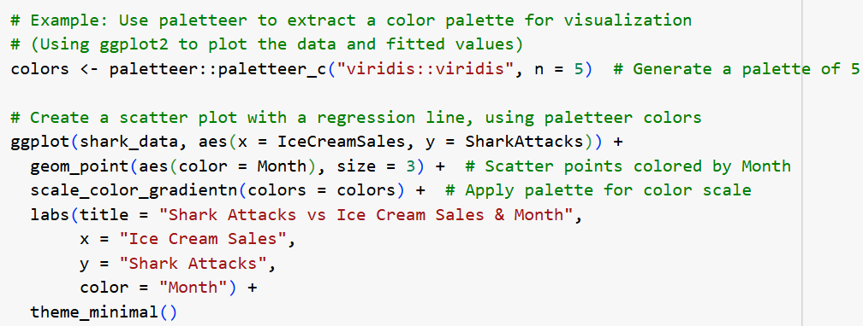
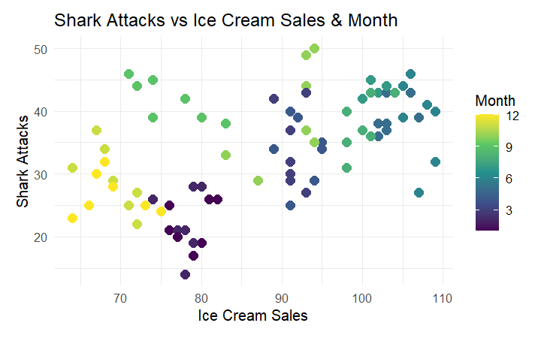

Datasaurus Dataset
Why do we need visualizations?
The Datasaurus Dozen is a famous dataset that demonstrates why visualizing data is essential rather than relying solely on summary statistics. The dataset consists of multiple sets of data points that all have identical summary statistics—such as the mean, variance, correlation, and regression line—yet look drastically different when plotted.
Why Does This Matter?
If we only looked at the numbers, we might assume all these datasets have the same distribution and relationships. However, visualizing them tells a completely different story:
- One dataset might form a linear relationship, while another forms a dinosaur shape, a circle, or a random cloud of points.
- This means that relying purely on statistics can hide important patterns, trends, or even misleading relationships in the data.
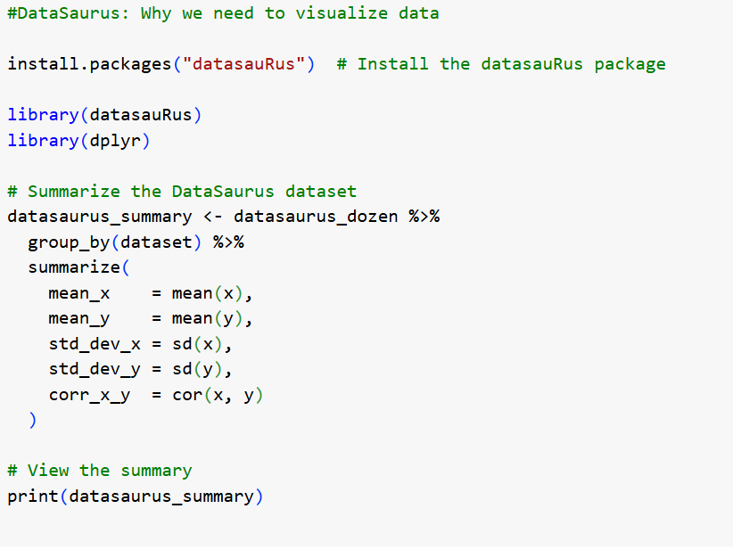
Summary statistics: As you can see they are very similar for our 13 data sets!
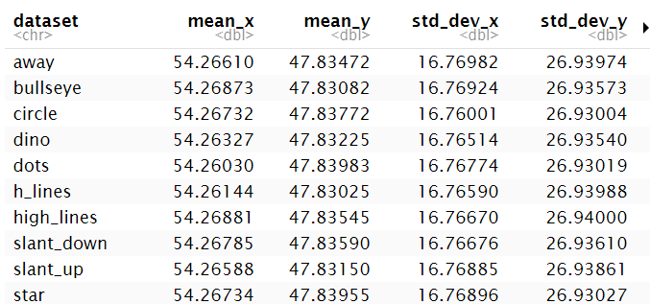

But once visualized…

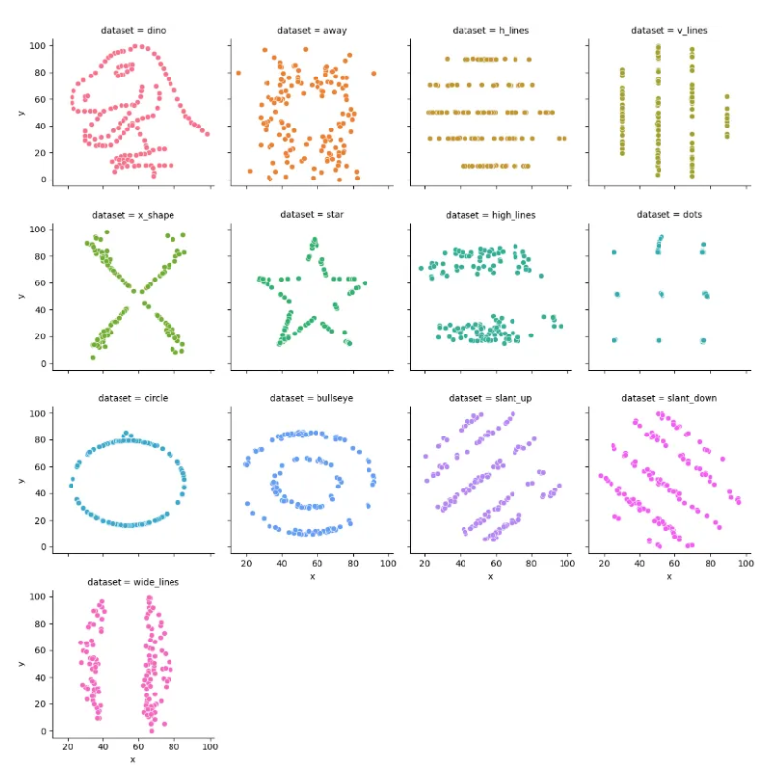
We can see that relying purely on statistics can hide important patterns, trends, or even misleading relationships in the data.

How can I continue my learning?

If you're looking to keep building your programming skills, there are plenty of great resources available!
- Check out ByteCraft – a free website I created that points students to free resources for learning R, Python, and other programming languages.
- Platforms like Coursera and LinkedIn Learning offer high-quality courses on R, data science, and programming. These courses often include hands-on exercises and certifications that can help strengthen your skills. See if your university offers a free LinkedIn Learning account! As for Coursera, if you do not want a certificate, you can take their courses for free. I have instructions outlined on ByteCraft on how to do that.
Continuous learning is key to becoming confident in R and programming in general, so take advantage of these resources and keep practicing!

